BSPS Area 7 Early Spring Festival

Saturday 21st & Sunday 22nd March
Aston Le Walls Event Centre
Washbrook Farm
Aston le Walls
NN11 6RT

RIHS / BSPS Winter and Summer Championships
Saturday: All BSPS & UKPH RIHS and Winter Qualifiers

Sunday: RIHS Workers, SHB(GB) Workers and Flat Classes, BSHA RIHS Qualifiers including Amateurs and Working Show Horse, RoR classes

North of England Summer Show qualifiers for
The Alan Marnie Supreme Ridden Mountain and Moorland, The Thomas Family Supreme Ridden Pony Championship (The Show Hunter Pony Champion) The Ellena Thomas Supreme Pretty Polly Ridden Championship (The Pretty Polly Champion)

Show secretary
Louise Gaunt
lougaunt0@gmail.com
Tel 07814 028539
Coursebuilder: Rachel Turner
Entries Opening Via Entry Master Opening late February and will be strictly limited, Entries Closing as soon as full or 14th March, whichever is soonest. Late entries will be taken online and Entries a taken on the day at extra cost – cash only

https://bspsarea7.entrymaster.online/

Competitors are encouraged to print their own back number to avoid queuing on the day. Back numbers will be available at the show on production of the confirmed entry

The safety and security of persons and animals attending the show is of paramount importance to the organisers of the show. Competitors and all those attending the show are reminded of their obligations under Health & Safety legislation to adhere to the safety instructions of stewards and officials at all times, and to adhere to written instructions and signs relating to safety of others who may be affected by their actions

Saturday 21st March
Ring 1 8am kindly sponsored by Scott Dixon Equine
1 Young Plaited Pony of the Year (Winter Q) Mrs M Ludlow
2 Novice Mixed Height SP Mrs M Ludlow
3 Novice Mixed Height SHP Mrs C Whiteley
4 Novice Intermediate RH/Hack/ SH Mrs C Whiteley
5-7 RIHS Open Intermediate SH/Hack/SH Mr R Parker Jones
8-11 RIHS Open Show Hunter Pony Mrs M Ludlow
12 RIHS Young Dragonara Riders Championship Mrs S Thomas

Not before 12 noon
13 RIHS Anglo and Part Bred Arab - Large Mr R Parker Jones
14 Pretty Polly Show Pony (RIHS) Mrs S Thomas
15 Pretty Polly Show Hunter Pony (RIHS) Mrs S Thomas
16-17 Heritage PP Minis (RIHS) Mrs S Thomas
18 Heritage Pretty Polly (RIHS) Mrs S Thomas
Pretty Polly Supreme Mrs S Thomas
19 Best of the Best TBC
Ring 2 8am Kindly sponsored by Ben Pauling Racing
20 Young Heritage Ridden (Winter Q) Mrs R Newman
21 Novice Mixed Height Heritage Ridden Mrs R Newman
22-25 RIHS UKPH M&M Young Riders & Amateurs Mrs J Griffin
26 UKPH Mini Juniors Mrs J Griffin
27-28 Heritage LR & 1st Ridden (RIHS Mrs C Whiteley
29-33 Heritage Open Ridden (RIHS) Mrs C Whiteley
Not before 1pm
34 Tiny Tots Lead Rein (plaited or Heritage) Mrs M Ludlow
35 Novice First Ridden (plaited or Heritage) Mrs M Ludlow
36-39 Lead Rein, 1st Ridden & LRSHT & 1st Ridden SHT (RIHS) Mr R Parker-Jones

Ring 3 8.00am Kindly sponsored by Gwynne Dental
40 Tiny Tots / Starter Stakes Mrs S Thomas
41 60cm Winter Worker Stakes (Winter Q) Mrs S Thomas
42 70cm Winter Worker Stakes (Winter Q) Mrs S Thomas
43 80cm Winter Worker Stakes (Winter Q)
44 90cm Winter Worker Stakes (Winter Q)
45 100cm Winter Worker Stakes (Winter Q)
46 Challenge Mixed Height Heritage WHP (+143 first) Mrs J Griffin
Not before 11.30
47 RIHS Cradle Stakes Mr P Hilton (J) & Mrs R Newman (C)
48 RIHS Nursery Mr P Hilton (J) & Mrs R Newman Not before 1.30pm
49 RIHS 133cm whp Mr P Hilton (C)& Mrs R Newman(J)
50 RIHS 143cm whp Mr P Hilton (C)& Mrs R Newman(J)
51 RIHS 153cm whp Mr P Hilton (C)& Mrs R Newman(J)
52 RIHS Intermediate WH Mr P Hilton (C)& Mrs R Newman(J)

IT IS STRONGLY RECOMMENDED THAT COMPETITORS HAVE ADEQUATE THIRD PARTY INSURANCE

Sunday 22nd March

Ring 1 08.00 Kindly sponsored by Scott Dixon Equine
53 4yr old hunter Mrs M Hopkins
54 Unaffiliated Novice Hunter Mrs M Hopkins
55-56 RIHS / UKPH Amateur Hunters Mr J Van Praagh (R) Mr T Wigget (C)
57 Novice Riding Horse Mr J Knight (R) Mr D Ingle (C)
58 Novice Cobs Mr J Knight (R) Mr D Ingle (C)
59 Novice Hacks Mr J Knight (R) Mr D Ingle (C)
Novice Championship (classes 53 & 57-59)
Not before 10am
60-61 RIHS Riding Horse Mr J Knight (R) Mr T Wigget (C)
Riding Horse Championship
62-64 RIHS Cobs Mr J Knight (R)Mr T Wigget (C)
Cob Championship
65-66 RIHS Hacks Mr J Knight (R) Mr T Wigget (C)
Hack Championship
Not before 12 noon
67 BSHA Racehorse to Show Horse Mr J Van Praagh (R) Mr D Ingle (C)
68 RIHS Small Hunter Mrs M Hopkins (R) Mrs H Hillard (C)
69-71 RIHS LW, MW & HW Hunter Mrs M Hopkins (R) Mrs H Hillard (C) Hunter Championship
Not before 2pm
72-75 RIHS/UKPH Amateur Riding Horse, Cob & Hack Mr J Van Praagh (R)
Amateur Championship

Ring 2 AM TBC Ring kindly sponsored by Ben Pauling Racing
2pm Ring kindly sponsored by Ben Pauling Racing
76 Tattersalls RoR Novice Ridden Series Mrs J Callwood (R) Mr D Ingle (C)
77 Tattersalls Open Ridden Series Mrs J Callwood (R) Mr D Ingle (C)
78 Tattersalls Amateur Ridden Mrs J Callwood (R) Mr D Ingle (C)
Ring 3 8.30am Kindly Sponsored Gwynne Dental
79 Style & Performance 80cm
80 Style & Performance 90cm
81 Style & Performance 100cm
Not before 11am
82 RoR Challenge Mrs J Callwood (R) Mr D Ingle (C) 83 Working Show Horse Mr J Knight (R) Mr D Ingle (C)
84 Novice Working Hunter (unaffiliated) Mrs J Callwood (R)
Not before 2pm
85 RIHS Lightweight WH Mrs M Hopkins (R) Mrs H Hillard (C)
86 RIHS Heavyweight WH Mrs M Hopkins (R) Mrs H Hillard (C)
RIHS Working Hunter Championship

Entry Fees RIHS Quals Other classes
Pre 12th March £40 (inc RIHS levy £12) £25
Late Entries £55 (inc RIHS Levy £12) £30 (if classes are not full)
First Aid £7 per rider

Prize Money (to be paid via Bank Transfer after the show)
RIHS Classes 1st £35 2nd £10 3rd £5
If less than 5 entries in any class, only 1st prize will be awarded
If only 1 entrant, no prize money will be awarded

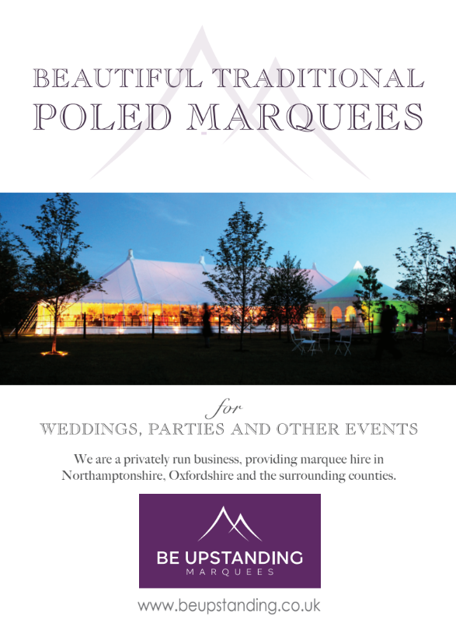

Saturday 21st March
Ring 1 0800 Kindly sponsored by Scott Dixon Equine
1 THE BSPS Young Plaited Pony/Horse of the Year Mares or geldings 4yrs, 5yrs and 6yrs. This class is open to Show Ponies, not exceeding 148cms. Show Hunter Ponies not exceeding 153cm and Intermediates not exceeding 160cm. Riders any age, but must be suitably mounted for the animal they ride
2 BSPS Novice Mixed Height Show Pony Mare or Gelding, 4 years old or over, not exceeding 148cms. Riders should be the correct age for the height of pony they ride
3 BSPS Mixed Height Novice Show Hunter Pony Mare or Gelding, 4 years old or over, exceeding 133cms but not exceeding 153cms. Riders must be the correct age for the height of pony they ride
4 Novice Intermediate RH/H/SH Mare or gelding exc 146cm but not exceeding 160cm. Riders not to have
attained their 25th birthday before 1st Jan in the current year
5 RIHS Intermediate Show Riding Horse Mare or gelding 4yrs old and
over, exceeding 148cm but not exc 158cm. Riders not to have attained their 25th birthday
before 1st Jan in the current year.
6 RIHS Intermediate Show Hack, Mare or gelding 4 years old or over exceeding 146cm and not exceeding 160cm. Riders not to have attained their 25th birthday before 1st Jan in the current year.
7 RIHS Intermediate Show Hunter, Mare or gelding 4yrs old or over, exceeding 148cm but not exc 158cm. Riders not to have attained their 25th birthday before 1st Jan in the current year.
RIHS Intermediate championship
(1st and 2nd prize winners in classes 5-7 to compete)

8 RIHS Open 123cm Show Hunter Pony Mare or gelding 4yrs old or over, not exceeding 123cm.
Riders not to have attained their 12th birthday before 1st Jan in the current year
9 RIHS Open 133cm Show Hunter Pony Mare or gelding 4yrs old or over, exc 123cm but not
exc 133cm. Riders not to have attained their 14th birthday before 1st Jan in the current year.
10 RIHS Open 143cm Show Hunter Pony Mare or gelding 4yrs old or over, exc 133cm but not
exc 143cm. Riders not to have attained their 17th birthday before 1st Jan in the current year
11 RIHS Open 153cm Show Hunter Pony Mare or gelding 4yrs old or over, exc 143cm but
not exc 153cm. Riders no to have attained their 20th birthday before 1st Jan in the current year
RIHS Open Show Hunter Pony Championship
(1st & 2nd Prize winners in classes 8-11 to compete) for The Area 7 Rosebowl
The Champion will qualify for “The Thomas Family” Supreme Ridden Pony Championship to be held at the NORTH OF ENGLAND SUMMER SHOW on 28th June 2026

12 RIHS Young Dragonara Riders Championship. Mare or gelding 4yrs old or over, not exceeding 153cm of show pony or show hunter pony type. Riders not to have attained their 20th birthday on 1st January in the current year. Riders not to have ridden in any class at HOYS (except lead rein and Search for a Star), or LIHS Heritage Supreme Championship and not to have been place 1st – 8th in any ridden show class at RIHS (except Lead Rein and Pretty Polly classes) in 2024 and 2025. Riders must be suitably mounted and ponies must not be undersized for the rider. Ponies and riders may be professionally produced as long as they adhere to the above criteria. Ponies will be required to walk, trot and canter all together on the go round
Not before 12 noon
13 RIHS Ridden Anglo and Part Bred Arab. Mare, Stallion or Gelding 4 years old or over exceeding 148cms. Riders any age.
14 RIHS Pretty Polly Mixed Height Show Pony Mare or gelding 4yrs old or over not exc 148cm. Riders in the 128cms section must not have attained their 13th birthday before 1st January in the current year. Riders on ponies exceeding 128cms must not have attained their 18th birthday before 1st January in the current year
Kindly sponsored by the Radford-Jones family
15 RIHS Pretty Polly Mixed Height not exc 153cm Show Hunter Pony Mare or Gelding, 4 years old and over.
Not exceeding 133cms riders not to have attained their 14th birthday before 1st Jan in the current year. Exceeding 133cm but not exc 153cm, riders not to have attained their 20th birthday before 1st Jan in the current year Kindly sponsored by the Radford-Jones family
16 RIHS Pretty Polly Heritage Open Lead Rein Mare or gelding 4 yrs old or over, not exc 122cm. Riders not to have attained their 9th birthday before 1st Jan in the current year. Kindly sponsored by the Radford-Jones family

17 RIHS Pretty Polly Heritage Open First Ridden Mare or gelding 4 yrs old or over, not exc 128cm.
Riders not to have attained their 12th birthday before 1st Jan in the current year Kindly sponsored by the Radford-Jones family

18 RIHS Heritage Pretty Polly Ridden—Mixed Breeds Pure Bred Dartmoor, Exmoor, Shetland, Welsh A, B, C & D, Connemara, New Forest, Fell, Dales, Highland, ponies, 4 years old or over. Riders any age Kindly sponsored by the Radford-Jones family

RIHS Pretty Polly Supreme Ridden
The winners of all the Pretty Polly classes to compete.
The Champion will qualify for Ellena Thomas Supreme Ridden Pony Championship , kindly sponsored by “The Ellena Thomas” to be held at the NORTH OF ENGLAND SUMMER SHOW on 28th June 2026. If the Champion has already qualified then the Reserve Champion will go forward. Only the Champion or Reserve Champion will qualify.
Exhibitors who qualify for the final will be sent details directly from: The Secretary, North of England Summer Show, Blue Slate Stables, Showley Rd., Clayton-le-Dale, Lancs, BB1 9DP

19 Best of the Best Area 7 Member Championship The highest placed Area 7 members from all BSPS classes to compete. Champion to go through to Best of the Best at BSPS Summer Championship show. To be eligible for qualification ANIMALS MUST BE REGISTERED, OWNED & RIDDEN WITH THE B.S.P.S AND must be MEMBERS OF THE RELEVANT AREA.

Ring 2 8am Kindly sponsored by Ben Pauling Racing
20 THE BSPS Young Heritage Pony of the Year Registered Stallion, Mare or Gelding. 4, 5 or 6 yrs. old. Riders any age but must be suitably mounted for the animal they ride
21 BSPS Heritage Mountain and Moorland Novice Ridden. Ponies 4 yrs old or over, riders any age

UK PONIES & HORSES LIMITED & ANTHONY EVANS INSURANCE BROKERS
RIHS YOUNG RIDERS MOUNTAIN & MOORLAND RIDDEN FINAL 2026
RIHS AMATEUR RIDERS MOUNTAIN & MOORLAND RIDDEN FINAL 2026
TO BE HELD AT THE ROYAL INTERNATIONAL HORSE SHOW, HICKSTEAD, WEST SUSSEX, RN17 5NU IN JULY 2026
TO BE JUDGED IN ACCORDANCE WITH THE RULES OF UK PONIES & HORSES LIMITED.
Owners must be Adult / Life Members, Riders must be current UK Ponies & Horses Limited Annual Members and the ponies currently registered with UK Ponies & Horses Limited before time of entry in order to compete in these classes. Open to Mountain and Moorland Ridden Stallion (Intermediate class only), Mare or Gelding, 4 years old and over. Registered in their approved Pure Breed Society Stud Books of Connemara, Dartmoor, Dales, Exmoor, Fells, Highland, New Forest, Shetland, Welsh A, B, C or D. The highest placed exhibit not already qualified within the first five from classes 58-61 will qualify for the UK Ponies & Horses Limited RIHS Young Riders M&M Ridden.
22 RIHS UK Ponies & Horses Ltd & Anthony Evans Insurance Brokers M&M Small Breeds – Mare or Gelding, 4 years old & over. Registered in their approved pure Breed Society stud books of Dartmoor, Exmoor, Shetland, Welsh Section A or B. Rider not to have attained their 14th Birthday before the 1st January in the current year.
23 RIHS UK Ponies & Horses Ltd & Anthony Evans Insurance Brokers M&M Large Breeds – Mare or Gelding, 4 years old & over. Registered in their approved pure Breed Society stud books of Connemara, Dales, Fell, Highland, New Forest Welsh Section C or D. Rider not to have attained their 18th Birthday before the 1st January in the current year.
24 RIHS UK Ponies & Horses Ltd & Anthony Evans Insurance Brokers RIHS Intermediate M&M – Stallion, Mare or Gelding, 4 years old & over. Registered in their approved pure Breed Society stud books of Connemara, Dales, Dartmoor, Exmoor, Fell, Highland, New Forest, Shetland, Welsh Section A, B, C or D. Rider not to have attained their 25th Birthday before the 1st January in the current year.
UKPH Ponies & Horses Young Riders Championship
(1st & 2nd prizewinners in classes 22-24 to compete)

25 RIHS UK Ponies & Horses Ltd & Anthony Evans Insurance Brokers Amateur Rider Ridden M&M - Mountain and Moorland ridden Stallion, Mare or Gelding 4 years old and over, registered in their approved Pure Breed Society stud Books of Connemara, Dartmoor, Dales, Exmoor, Fells Highland, New Forest, Shetland , Welsh A,B.C,D rider any age. The highest placed pony and rider not already qualified within the first five will qualify for the UK Ponies & Horses Limited RIHS Amateur Riders M&M Finals at the RIHS Hickstead in July 2026. Qualification will be verified by the office.
26 UK Ponies & Horses Mini Juniors - Mare or Gelding, 4 years old & over. Small Breeds only, registered in their approved Pure Breed Society stud books of Dartmoor, Exmoor, Shetland, Welsh Section A or B. Riders to have attained their 8th birthday but not their 13th Birthday before the 1st of January in the current year.
Combinations would not be required to become a Member of UK Ponies & Horses to
compete.
27 RIHS Heritage Open Lead Rein Mare or gelding 4 yrs old or over, not exc 122cm, riders not to have attained their 9th birthday before 1st Jan in the current year
28 RIHS Heritage Open First Ridden Mare or gelding 4 yrs old or over, not exc 128cm. Riders not to have attained their 12th birthday before 1st Jan in the current year

RIHS Heritage Mini Championship
(1st and 2nd prize winners in classes 27 & 28 to compete)

29 RIHS Heritage Mountain & Moorland Open Ridden Welsh Sectıon A & B. Ponies 4yrs old or
over. Riders any age
30 RIHS Heritage Mountain & Moorland Open Ridden Dartmoor, Exmoor, Shetland . Ponies 4yrs
old or over. Riders any age
31 RIHS Heritage Mountain & Moorland Open Ridden Fells, Highlands Dales . Ponies 4yrs old or
over. Riders any age
32 RIHS Heritage Mountain & Moorland Open Ridden New Forest, Connemara. Ponies 4yrs old
or over, Riders any age
33 RIHS Heritage Mountain & Moorland Open Ridden Welsh Section D & C. Ponies 4yrs old or
over. Riders any age

RIHS Heritage Mountain & Moorland Open Ridden Championship
(1st & 2nd prizewinners in classes 29-33 to compete for the M&M Statue )
The Champion will qualify for “The ‘Alan Marnie” Supreme Ridden Pony Championship to be held at the NORTH OF ENGLAND SUMMER SHOW on 28th June 2026
If the Champion has already qualified then the Reserve Champion will go forward.
Only the Champion or Reserve Champion will qualify.
Exhibitors who qualify for the final will be sent details directly from:
The Secretary, North of England Summer Show, Blue Slate Stables, Showley Rd., Clayton-le-Dale, Lancs, BB1 9DP

Not before 1pm
34 Unaffiliated Tiny Tots Lead Rein – Plaited or Heritage. Ponies not exceeding 122cm, rider not to have attained their 6th birthday by 1st Jan in the current year
35 Unaffiliated Novice First Ridden – Plaited or Heritage. Ponies not exceeding 128 cm, rider not to have attained their 12th birthday by 1st Jan in the current year
36 RIHS Lead Rein Show Pony Mare or gelding 4yrs old or over, not exceeding 122cm. Riders not to have
attained their 8th birthday before 1st Jan in the current year
37 RIHS First Ridden Show Pony Mare or gelding 4yrs old or over, not exceeding 123cm. Riders not to have
attained their 10th birthday before 1st Jan in the current year
38 RIHS Lead Rein of Hunter Type Mare or gelding 4yrs old or over, not exc 122cm. Riders not to have attained their 9th birthday before 1st Jan in the current year
39 RIHS First Pony of Show Hunter Type Mare or Gelding 4 years old or over, not exceeding 123cms. Suitable to be ridden by a rider not to have attained their 10th. birthday before the 1st. January in the current year.

RIHS Mini Championship
(1st and 2nd prizewinners in classes 36-39 to compete)

Ring 3 8am Kindly sponsored by Gwynne Dental
40 Tiny Tots / Starter Stakes Mare or gelding 4yrs old or over, not exc 122cm. Riders not to have attained their 9th birthday before 1st Jan in the current year
41 60 cm WINTER WORKER STAKES Plaited or Heritage Mountain and Moorland ponies, 4 years old and over not exceeding 158cms. Riders any age but must be suitably mounted for the pony/horse they ride. An award card will be presented to the highest placed child under 12 years of age on 1st January in the current year, in the class who will also qualify for the BSPS Winter Championships. Kindly sponsored by RJR Autos
42 70 cm WINTER WORKER STAKES Plaited or Heritage Mountain and Moorland ponies, 4 years old and over not exceeding 158cms. Riders any age but must be suitably mounted for the pony/horse they ride. An award card will be presented to the highest placed child under 14 years of age on 1st January in the current year who will also qualify for the BSPS Winter Championships. Kindly sponsored by RJR Autos
43 80 cm WINTER WORKER STAKES Plaited or Heritage Mountain and Moorland ponies, 4 years old and over not exceeding 158cms. Riders any age but must be suitably mounted for the pony/horse they ride. An award card will be presented to highest placed rider under 18 years of age on on 1st January in the current year in the class who will also qualify for the BSPS Winter Championships. Kindly sponsored by RJR Autos
44 90 cm WINTER WORKER STAKES Plaited or Heritage Mountain and Moorland ponies, 4 years old and over not exceeding 158cms. Riders any age but must be suitably mounted for the pony/horse they ride. An award card will be presented to the highest placed child under 18 years of age on 1st January in the current year in the class who will also qualify for the BSPS Winter Championships. Kindly sponsored by RJR Autos
45 100 cm WINTER WORKER STAKES Plaited or Heritage Mountain and Moorland ponies, 4 years old and over not exceeding 158cms. Riders any age but must be suitably mounted for the pony/horse they ride. An award card will be presented to the highest placed child under 25 years of age on 1st January in the current year in the class who will also qualify for the BSPS Winter Championships. Kindly sponsored by RJR Autos
In classes 41-45 The Highest placed 3 ponies will qualify for the BSPS Winter Championships together with the highest placed junior rider. Ponies may compete in more than one height section. FENCES There must be a minimum of 8 fences up to a maximum of 12 fences. Marks will be awarded: -
Jumping 70 marks
Style whilst jumping 30 marks
Conformation and Way of Going 20 marks
Total 120 marks

46 BSPS Challenge Mixed Height Heritage Working Hunter Pony Pure Bred Dartmoor, Exmoor, Shetland, Welsh A, B, C & D, Connemara, New Forest, Fell, Dales, Highland, ponies, 4 years old or over. Riders any age

Not before 11.30am
47 RIHS Cradle Stakes Mare or gelding 4yrs old or over, not exc 123cm. Riders not to have attained their 12th birthday before 1st Jan in the current year.
48 RIHS Nursery Stakes. Mare or gelding 4yrs old or over, not exc 133cm. Riders not to have attained their 13th birthday before 1st Jan in the current year The Joey B Plate.

Mini Working Hunter Pony Championship
1st & 2nd prizewinners in classes 47 & 48 to compete
Not before 1.30pm
49 RIHS Open 133 Working Hunter Pony Mare or gelding 4yrs old or over, not exc 133cm. Riders not to have attained their 15th birthday before 1st Jan in the current year. Kindly Sponsored by Notley Tythe Barn
50 RIHS Open 143 Working Hunter Pony Mare or gelding 4yrs old or over, not exc 143cm. Riders not to have attained their 18th birthday before 1st Jan in the current year. Kindly Sponsored by Notley Tythe Barn
51 RIHS Open 153 Working Hunter Pony Mare or gelding 4yrs old or over, not exc 153cm. Riders not to have attained their 25th birthday before 1st Jan in the current year Kindly Sponsored by Notley Tythe Barn
52 RIHS Open Intermediate Working Hunter Mare or gelding 4yrs old or over, not exc 158cm. Riders not to have attained their 25th birthday before 1st Jan in the current year Kindly Sponsored by Notley Tythe Barn

RIHS Working Hunter Pony Championship
(The 1st & 2nd placed competitors in classes 49-52 to compete) for the BSPS Area 7 Working Hunter Pony Champion’s Trophy

Sunday 22nd March
Ring 1 0800 Kindly sponsored by Scott Dixon Equine

53 SHB(GB) 4 yr old Hunter (will not be ridden)
54 Unaffiliated Novice Hunter, Mare or gelding four years old and over (see Novice classification at back of schedule).
55 RIHS Amateur Lightweight Hunter Mare or gelding four years old and over, capable of carrying up to 12 stone 7lbs, including small hunters. To be run under 2026 SHB(GB) Rules
56 RIHS Amateur Heavyweight Hunter Mare or gelding four years old and over, capable of carrying over 12 stone 7lbs (to include middleweight hunters). To be run under 2026 SHB(GB) Rules.
RIHS Amateur Championship
(1st & 2nd Prizewinners in classes 55 & 56 to compete)

BSHA EASY CHP NOVICE HACK, COB, MAXI COB AND RIDING HORSE
EASY CHIP NOVICE SERIES QUALIFIER Owners, Riders and Horses must be registered with BSHA or have temporary membership With a Day/Show Ticket. The highest placed unqualified horse in the top three in each class will qualify for the Easy Chip Novice Final at the BSHA National Championship Show in September. Horses competing as four and five-year-olds in BSHA classes, will retain Novice status, irrespective of any wins, placings or prize money accrued, unless they have been placed 1st – 5th at HOYS or RIHS in any OPEN Ridden class (with the exception of the Search for A Star Finals). Horses competing as a six year old or over, in BSHA classes, will retain Novice status unless they have been placed 1st – 5th at HOYS or RIHS in any OPEN Ridden class, BSHA or otherwise, (with the exception of the Search For A Star Finals) or have won a first prize of £25 or over in any showing class, excluding Working Show Horse Classes, Rising Star classes and finals, Ladies Show Horse or In-Hand classes, that were Affiliated to the Association, at home or abroad, prior to 1st January in the current year. Winnings as a four-year-old are exempt. If a horse changes category (ie from a Hack to a Riding Horse or vice versa), it may not revert to a Novice. Snaffle bridles may be worn for Novice classes.
.
57 Novice Riding Horse Mare or gelding 4yrs old and over, exceeding 148cm
58 Novice Cob: mare or gelding, 4 years old and over, exceeding 148cms
59 Novice Hack Mare or gelding 4yrs old and over, exceeding 148cm but not exceeding 160cm
Novice Championship
(1st & 2nd Placed competitors from classes 55 & 59-61 to compete)
Not before 10am
Held under the rules of the British Show Horse Association. Horses must be registered with the Association, and all Owners, Exhibitors, Producers and Riders must be Association Members. Riders must be 15 years of age or older. Registration numbers must be quoted on the entry form.
Classes 60-66 are qualifiers for The Royal International Horse Show. The first prize winner will qualify to compete at the final. If already qualified, the second will qualify. If the first and second are already qualified then the third will go forward, with the exception of BSHA shows, where qualification will go down the line. Competitors qualifying at this show for the Agria Royal International Horse must submit their entries ONLINE at: https://www.hickstead.co.uk/entries-results-schooling/the-agria-royal-international-horse-show/ Horses competing at the RIHS and qualifying shows in Hunter sections of The Sport Horse Breeding of Great Britain at their Affiliated Shows cannot compete in Hack, Cob and Riding Horse classes at the same show and vice versa. This does not apply to SHB (GB) Ridden Sport Horse classes. The BSHA offers a Novice, Young Rider and Amateur Rosette in each Open class and a Champion Rosette for each section.
BSHA CLASSIC OF THE YEAR FINAL
The highest placed unqualified exhibit in the top five in each Open Affiliated class (Hack, Cob, Maxi Cob, Riding Horse) will qualify to compete in the BSHA Classic of the Year Final. The Finals will be held at the BSHA National Championship Shows in September 2026.

60 RIHS Small Riding Horse: mare or gelding, 4 years old and over, exceeding 148cms and not exceeding 158cms. Kindly Sponsored by Cotswold Canapes
61 RIHS Large Riding Horse: mare or gelding, 4 years old and over, exceeding 158cms Kindly Sponsored by Cotswold Canapes
Riding Horse Championship
(1st & 2nd Prizewinners in classes 60 & 61 to compete)

62 RIHS Lightweight Cob: mare or gelding, 4 years old and over, exceeding 148cms, but not exceeding 155cms, capable of carrying up to 14 stone.
63 RIHS Heavyweight Cob: mare or gelding, 4 years old and over, exceeding 148cms, but not exceeding 155cms, capable of carrying more than 14 stone.
Cob Championship
(1st & 2nd Prizewinners in classes 62 & 63 to compete)

64 RIHS Maxi Cob: mare or gelding, 4 years old and over, exceeding 155cms – with a recommended height limit of 160cms - to be judged as Cobs. Judges must pay particular attention to type (i.e. short legged animals of COB type). To be shown hogged (showing no significant growth

65 RIHS Small Hack: mare or gelding, 4 years old and over, exceeding 148cms, but not exceeding 154cms.
66 RIHS Large Hack: mare or gelding, 4 years old and over, exceeding 154cms, but not exceeding 160cms
Hack Championship
(1st & 2nd place prizewinners in classes 65 & 66 to compete)

Not before 12 noon Ring Kindly sponsored by Ben Pauling Racing
Class 67 is held under the rules of the British Show Horse Association. Owners, Riders, In- Hand Handlers &
Horses must be registered or have temporary membership with a Day/Show Ticket. Horses registered with
the Association must be Owned, Exhibited, Produced and Ridden by current BSHA Members. Riders must be
15 years of age or older. Registration numbers must be quoted on your entry form.
67 BSHA Open Racehorse to Show Horse Mare or gelding, 4 years old or over, exceeding 148cm. Open to thoroughbred and Arab horses retired from race training. The class will run as an open ridden class; therefore, all exhibits will be ridden by the judge and may be required to gallop. Open to registered BSHA members and non-members, including those who work with the horse racing industry. The two highest placed unqualified exhibits qualify for the final at the BSHA National Championship Show; non-members must apply for a day-ticket for the BSHA National Championship Show in order to compete in the final.
68 RIHS Small Hunter Mare or Gelding, four years old or over, exceeding 148cm (14.2hh approx) but not exceeding 158cm (15.2hh approx. Any mare or gelding, 4 years old or over exceeding 148 cm (14.2hh approx.) but not exceeding 158 cm (15.2hh approx.). A horse, which is registered as a Small Hunter, cannot compete in an Open Weight Class. Animals in ridden height restricted classes WILL NOT be required to be in possession of a JMB Height Certificate or verification of measurement to compete in RIHS or HOYS Qualifiers. However qualifying animals will need to be measured WITHIN 28 DAYS OF QUALIFICATION OR BEFORE THE FINAL, WHICHEVER IS SOONER. The valid JMB full height certificate or a valid JMB annual height certificate must be submitted to the SHB(GB) office on receipt from the JMB and prior to competing at RIHS or HOYS. There are NO exceptions to this rule.

69 RIHS Lightweight Hunter Mare or Gelding, four years old or over, capable of carrying up to 12 stone 7lbs.
70 RIHS Middleweight Hunter Mare or Gelding, four years old or over, capable of carrying over 12 stone 7lbs and not exceeding 14 stone.
71 RIHS Heavyweight Hunter Mare or Gelding, four years old or over, capable of carrying over 14 stone.
Hunter Championship
(1st & 2nd prize winners in classes 69-71 to compete)

RIHS AMATEUR QUALIFYING CLASSES
Classes 72-75 are qualifiers for the Amateur Championships at The Royal International Horse Show. The highest placed unqualified horse in each section in each class in the Hack, Cob and Riding Horse classes will qualify for the RIHS Amateur final, with the two highest placed unqualified horses qualifying in the Maxi Cob class The BSHA offer a Champion rosette to be awarded in the separate Amateur Championship. Please refer to rule 6a-c in the 2026 BSHA Rulebook. The Amateur qualifying classes may be entered on a day ticket, but appropriate membership and horse registration must be applied for within 14 days of the qualifier in order to confirm qualification. Competitors qualifying at this show for the Agria Royal International Horse Show must submit their entries ONLINE at: https://www.hickstead.co.uk/entries-results-schooling/the-agria-royal-international-horse-show/
Not before 2pm
72 RIHS Amateur Riding Horse: Mare or Gelding, four years old or over, capable of carrying over 14 stone
73 RIHS Amateur Cob: mare or gelding, 4 years old and over, exceeding 148cms, but not exceeding 155cms,
74 RIHS Amateur Maxi Cob: mare or gelding, 4 years old and over, exceeding 155cm – with a recommended height limit of 160cms - to be judged as Cobs. Judges must pay particular attention to type (i.e. short legged animals of COB type). To be shown hogged (showing no significant growth)
75 RIHS Amateur Hack: mare or gelding, 4 years old and over, exceeding 148cms, but not exceeding 160cms
Amateur Championship
(1st & 2nd prize winters in classes 72-75 to compete)

Ring 2 Kindly sponsored by Ben Pauling Racing

Warm up until 2pm
Tattersalls RoR Ridden Show Series classes
76 Tattersalls RoR NOVICE Ridden Show Series Qualifier 2026 Thoroughbred mare or gelding, 4 years old or over, any height, must have raced in GB and have current RoR competition membership. Riders must be 15 years or over on the 1st January of the calendar year holding the classes.Horses should be ridden in a snaffle, pelham or simple double bridle with a plain cavasson noseband. Horses should be plaited.
All those entering horses and/or participating in the show agree to be bound by the Retraining of Racehorses Rules and Regulations from time to time in force. Competitors/handlers/grooms must wear a safety/kite mark hard hat with a chinstrap. Racing injuries and blemishes are NOT ignored in this series.
The first three go forward to the Final at The Jockey Club RoR National Championships Aintree, August 2026
Prizes - Rosette 1st -4th and a RoR branded prize to be redeemed from the RoR Office
To take part in this class, horses must NOT have won: a ridden open class under any affiliated showing society (inc SEIB/HOYS, BSHA, SHB(GB) BSPS, BSPA, Tattersalls RoR Open /Amateur Ridden Show Series Qualifier, TARRA Ridden, or any other open class except Tattersalls (TBA) RoR Challenge Show Series, other Working Hunter type classes or In Hand. Unaffiliated Show wins are not considered. Horses may remain in the Tattersalls RoR Novice Ridden Show Series (Formerly RoR Jockey Club Novice Show Series) classes until they have won (win) three Tattersalls RoR Novice Show Series Qualifiers. They are de-noviced on their third novice win or at midnight on the day they win an open class, whichever happens first. They are still eligible to compete in the Tattersalls RoR Novice Final at The Jockey Club RoR National Championships.
77 Tattersalls RoR Open Ridden Show Series Qualifier 2026 Thoroughbred mare or gelding, 4years old or over, any height. Riders must be 15 years or over on the 1st January 2025 Horses should be ridden in a snaffle, pelham or simple double bridle with a plain cavasson noseband. Horses should be plaited. The first THREE go forward to the championship at Hickstead on June 2026. All entries MUST be competition registered with the RoR and include their competition registration number on entry form and have RACED in GB. All those entering horses and/or participating in the show agree to be bound by the Retraining of Racehorses Rules and Regulations from time to time in force’ Please be aware that the show will split the class on the horse’s last run in a race (NH or Flat) or will provide 2 ride judges should the entries exceed 20. Please mark your entry form accordingly. Competitors must wear a safety/kite mark hard hat with a chinstrap. Racing injuries and blemishes will NOT be ignored in this series
Prizes : Rosettes 1st – 4th and a RoR branded prize to be redeemed from the RoR Office
Veteran prize (15+) - and a RoR branded price to be redeemed from the RoR Office and qualification for the Veteran Final at the RoR National Championships at Aintree.
78 Tattersalls RoR Amateur Ridden Show Series Qualifier 2026 Open to all RoR and NR competition registered horses, 4yrs and over, mares and geldings, owned, produced and ridden by an Amateur. Riders must be 15 years or over on the 1st January of the calendar year holding the classes. Horses should be ridden in a snaffle, pelham or simple double bridle with a plain cavasson noseband. Horses should be plaited.
The Series is open to AMATEURS only – those employed in racing will be allowed to compete. Class will be judged under ‘riding horse’ format without ‘type’ being taken into consideration.
Racing injuries and blemishes ARE IGNORED in this series The Judge will not ride at the qualifiers but will ride in the final. Competitors/handlers/grooms must wear a safety/kite mark hard hat with a chinstrap.
The first three go forward to the final at the Hickstead Derby Meeting June 2026
RoR Rosettes 1st – 4th and a RoR branded price to be redeemed from the RoR Office
Amateur definition: The rules are as in the rulebook with the following addition that an amateur may not show a horse owned or sponsored by a company or commercial firm. In addition, a person classed as amateur must not be supported by a company in any way or act as brand ambassador whether financially or in-kind. An amateur is a person who for the purpose of RoR classes does not/has not during the current season or previous season:
Engage (d) in breeding, livery, buying or selling, dealing or hiring horses in a commercial capacity. Horses must not have been stabled at or reside in a Professional Producer's/Trainer's yard from January 1st, 2025. Riders must not have ridden any animals produced by a Professional/Trainer in the current or previous season. Horses and riders must not receive any help from a Professional Producer/Trainer at a SHOW in the current season. A rider who has ridden for a Professional/Producer Trainer in the current or previous season must not have ridden horses at a show. Any breaches of this ruling will be taken seriously and will result in disqualification from future classes.
RoR Championship
(1st and 2nd placed competitors in classes 82 and 76-78 to compete)

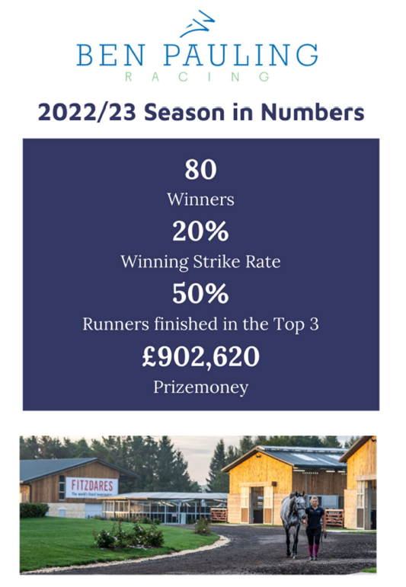

Ring 3 8.30am Kindly sponsored by Gwynne Denta

79 Style & Performance 80cm.
80 Style & Performance 90cm
81 Style & Performance 100cm
In classes 79-81 the water complex is an optional extra which is not marked and is purely for training
Not before 12 noon
82 Tattersalls RoR Former Racehorse Challenge Show Series Qualifier 2026 Horses must have raced in GB . Horses must have current RoR Competition Membership and riders must be 15 years old or over on the 1st of January 2026. Mare or gelding 4yrs old or over and of any height. Horses to be ridden in any suitable bridle and should be plaited.
Racing injuries and blemishes ARE IGNORED in this series. The first three go forward to the Final at the The Jockey Club RoR National Championships, Aintree in August 2026, Competitors must wear a safety/kite mark hard hat with a chinstrap. All those entering horses and/or participating in the show agree to be bound by the Retraining of Racehorses Rules and Regulations from time to time in force. The class to be judged 50% jumping, 20% Style while jumping and performance and 30% awarded for show, manners and suitability to be retrained Kindly sponsored by Snaffles Equine Nutrition

83 RIHS BSHA SEIB Open Working Show Horse
Class 83 is a qualifier for the Open Working Show Horse Championship at The Royal International Horse Show. All affiliated BSHA Open Working Show Horse classes held prior to 8th June 2026 are qualifiers for the Royal International Horse Show final and the SEIB Working Show Horse Final. For the RIHS qualification the highest placed unqualified in the top five will qualify. If the first has already qualified, the qualification may pass down to no lower than fifth place. For the SEIB Working Show Horse qualification, the two highest placed unqualified in the top 5 will qualify. .RIHS qualifying classes held after 1st August will carry the qualification forward to 2027 but only the WINNER will receive qualification in these cases. Open ONLY to Hacks, Cobs, Maxi Cobs and Riding Horses, mare or gelding four years old and over, exceeding 148cms. This class is NOT open to Hunters, ie those horses registered and competing as a hunter or working hunter with BSHA, Sport Horse Breeding of Great Britain or The Showing Register for the current season. Please refer to rule 2(iv) in the 2026 BSHA Rulebook. The Working Show Horse qualifying classes may be entered on a day ticket, but appropriate membership and horse registration must be applied for within 14 days of the qualifier in order to confirm qualification. Any Horse which is a Grade B Showjumper, Intermediate Eventer, or above, as at the 1st January of the current year, is not eligible to compete in any Working Show Horse class. A Rider may ride up to two Horses in the jumping phase but must then select one Horse to take through to the Ride and Conformation phases (if required). No change of Rider is allowed.

84 Unaffiliated Novice Working Hunter. A mare, gelding or stallion (competing stallions must have a red, white and blue ribbon displayed in their tail) four years old and over not to have won a total of £200, excluding championship prize money, (or equivalent values) in prize money in any SHB(GB) affiliated Working Hunter Class, or more than 5 BE points or 200 BS points, at home or equivalent abroad before 1st January in the relevant year. Fences in Novice Working Hunter classes should have a minimum height of 0.85m (2’9”) and a maximum height of 1.00m (3’3”).

Not before 2pm
In classes 85 & 86 the water feature will NOT be included
85 RIHS Lightweight Working Hunter Mare, gelding or stallion (competing stallions must have a red, white and blue ribbon displayed in their tail) four years old and over exceeding 148cm (14.2hh approx), capable of carrying up to `12 stone 7 lbs To be run under 2026 SHB(GB) Rules. Kindly sponsored by Snaffles Equine Nutrition
86 RIHS Heavyweight Working Hunter Mare, gelding or stallion (competing stallions must have a red, white and blue ribbon displayed in their tail) four years old and over exceeding 148cm (14.2hh approx), capable of carrying over 12 stone 7 lb To be run under 2026 SHB(GB) Rules Kindly sponsored by Snaffles Equine Nutrition
RIHS Working Hunter Championship
(1st & 2nd placed competitors in classes 85 & 86 to compete)

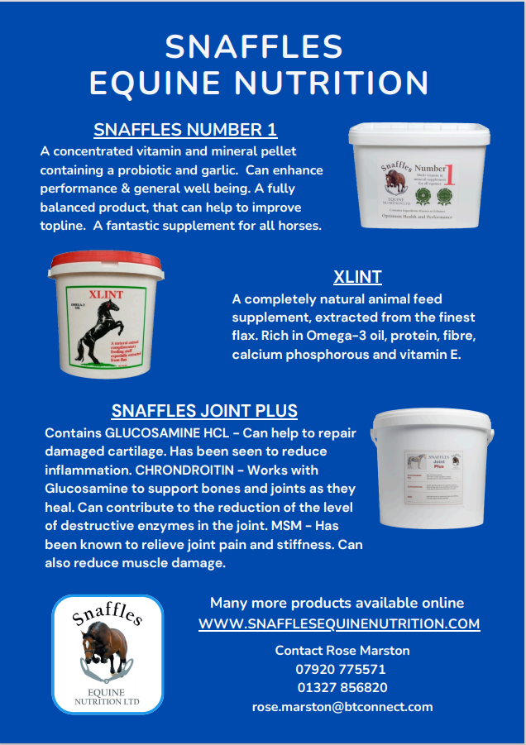

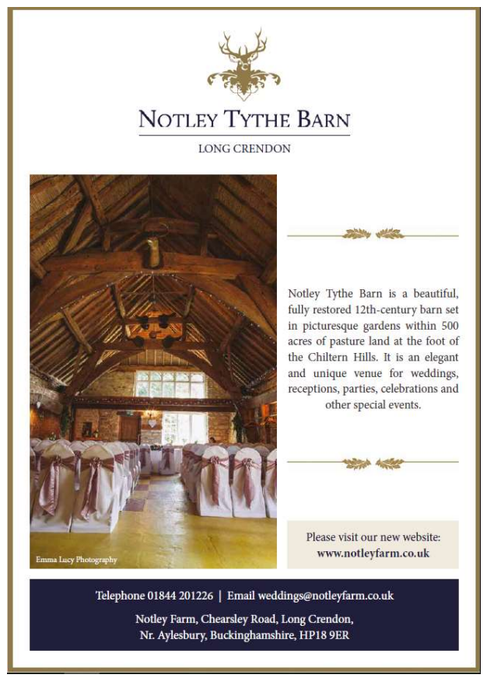

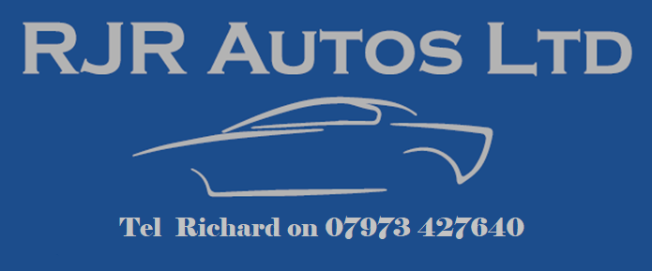



BSPS Area 7 are truly grateful to our most generous sponsors:

Gwynne Dental The Radford Jones Family
Ben Pauling Racing Notley Tythe Barn
RJR Autos Snaffles Equine Nutrition
Cotswold Canapes Be Upstanding Marquees
Holder Show Team Jasean Spraggett
Scott Dixon Equine

As well as our dedicated team of judges and stewards who volunteer to allow the show to go ahead

Rules and Regulations
Correctly secured Skull Caps/Riding Hats Nos. PAS015 2011, VG1, (BS) EN1384 2023, ASTM F1163 2015 and 2023, SNELL E2016 and E2021, AS/NZS 3838 2006, MUST be worn by riders at all times when mounted. Hats should have a plain cover, either Black, Navy Blue, Brown, Grey or Green. Velvet covers are encouraged.
The show is affiliated to the BSPS and all persons entering, competing, showing or otherwise taking part, whether or not members of the BSPS, are subject to the constitution and rules of the BSPS including disciplinary procedures and shall be deemed to have consented to the jurisdiction of the BSPS. Re Hats, please refer to rule 43 in the BSPS 2026 rule book
1.This show is affiliated to the British Show Pony Society, and all persons entering, competing, showing or otherwise taking part in these classes whether or not members are subject to the constitution and rules of this society including the disciplinary procedures and shall be deemed to have consented to the jurisdiction of this society.
2. All B.S.P.S. Classes will be judged under the rules in the 2026 B.S.P.S. Rule and Show Handbook.
3. The judge’s decision is final.
4. The judges named in this schedule have accepted the invitation to judge but the committee reserve the right to appoint a substitute for any judge who is unable to attend.
5. No nomination or substitution entries are allowed.
6. No spurs may be worn in B.S.P.S. Classes.
7. Objections should be made in writing with the objector’s full name and address, within an hour of the event taking place, and lodged at the secretary’s office with the sum of £10 deposit. The sum shall be returned if the objection is sustained. Any objection in respect of a J.M.B. Certificate will be dealt with in accordance with J.M.B. Rules.
8. The committee shall not, in any way be responsible for any loss, injury or damage that may happen to exhibitors or their assistants or other members of the public, or any animal or property or to any vehicle brought into the showground or onto any premises in conjunction with the show, or while entering or leaving the same.
9. Exhibitors shall be responsible for the behaviour of their assistants or riders and for the conduct of such assistants and riders and all persons in charge of exhibits shall be subject to the instructions given by the judges or stewards. No juvenile, mounted or un-mounted will be allowed in collecting ring without adult supervision.
10. This show is a qualifier for the 2026 BSPS Winter Championship Show to be held at Arena UK. 1st -3rd in classes 1, 20 and 41-45 to qualify provided that the animal is registered in accordance with rules 23 & 28 and ridden by a BSPS Member
11. This show is a qualifier for the R.I.H.S. Only one pony in each of the Open W.H.P. classes, Open S.H.P. classes, Leading Rein & First Ridden of Hunter Type, Cradle Stakes, Nursery Stakes, Open Intermediate Show Riding Horse, Show Hack and Show Hunter, and Open Heritage Ridden. and Open Heritage Lead Rein and First Ridden. The highest placed, (not already qualified) from the first three placed in each class will qualify. One pony in each of the Pretty Polly Classes qualifies. The highest placed, (not already qualified) from the first three placed in each class will qualify. Owners and riders must be B.S.P.S. Members and the pony registered with the B.S.P.S. to compete in classes with R.I.H.S. qualification.
12. This show is a qualifier for the Blue Riband Championships to be held at the B.S.P.S. Championship Show. The 1st and 2nd prize winners only in classes 27 & 28, 49-52, & 5-11 to qualify. Ponies must be owned registered and ridden by a B.S.P.S. Member to compete in these classes.
13. In the Intermediate classes riders over 18 years and up to 25 years must be showing members.
14. This show is a qualifier for the B.S.P.S. Challenge. Animals must qualify for the Challenge by attending any B.S.P.S. affiliated show and competing in the appropriate class:- Open Lead Rein, First Ridden, Lead Rein of Hunter Type, Open Show Pony, SHP, Open Cradle and Nursery Stakes, WHP, Intermediate SRT, SH and WH and Open Heritage Lead Rein, First Ridden, Ridden and WHP classes. Animals must not have qualified for 2026 HOYS. If an animal qualifies for HOYS it will forfeit its qualification for the BSPS Challenge
15. All Pretty Polly Classes will be run under B.S.P.S. Pretty Polly rules as laid out in the 2026 B.S.P.S. Rule & Show Handbook.
16. Royal International Horse Show. – The R.I.H.S. levy is £12.00 per entry. Owners and rides must be B.S.P.S. Members and the pony registered with the B.S.P.S. to compete in classes with qualification for the R.I.H.S.
18. Riders in all B.S.P.S. WHP classes MUST wear a body protector.
19. Owners and riders must be BSPS Members to qualify in the RIHS Anglo & Part-bred Arab Classes. Animals must be registered with the AHS – BSPS Rule 376.
ALL DOGS MUST BE KEPT ON LEADS. - Lorries are towed at the owners/exhibitor’s own risk.
This show is affiliated to the Sport Horse Breeding of Great Britain. Rules as per the 2026 handbook. The organisers of the show have taken reasonable precautions to ensure the Health & Safety of everyone present. For these measures to be effective everyone must take all reasonable precautions to avoid & prevent accidents occurring & must obey the instructions of the organisers and all the Officials & Stewards. Sport Horse Breeding of Great Britain require all exhibits in the Hunter Classes to be registered. Numbers to be stated on entry forms. All classes are subject to SHB (GB) Regulations. Any horse taking part will be liable for dope testing. Owners and riders must be current members of SHB (GB). Show Hunters must be registered in their correct weight class, but if a Judge considers an animal to be up to more than the specified weight he will transfer it to a higher weight class. If a horse’s registered weight is altered after the closing date of entries, it must still appear in the class for which it is entered and the revised registration certificate must be shown to the Judge and his permission sought to appear in the higher weight class. If a horse changes ownership after the closing date of entries, it must be re-registered in the name of the new owner before it is eligible to be shown, although it may not be possible to change the details printed in the catalogue.
Day Ticket = £45 (this entitles competitors to compete at a maximum of 2 show’s in the year at £45 per show – it covers owner and rider membership together with horse registration for that show). If the class is a qualifying class for RIHS, in order for the qualification to be valid, application for full owner/rider membership and horse registration must be received in the SHB(GB) office within 14 days.
Classes 55-56,& 68-71 are qualifying events for the Royal International Horse Show. The two highest placed horses in the Lightweight, Middleweight, Heavyweight, Small Classes will qualify to enter at the RIHS. No horse lower than second will qualify.
AMATEUR RULES DEFINITION.
a). It is expected that Exhibitors will compete in the true spirit of these Rules. The Directors / Board / Council reserve the right, in their absolute discretion, to reclassify an Exhibitor’s Amateur status/entry should they deem it necessary.
AMATEUR STATUS
A person is an Amateur for the purpose of classes run under Association Rules if he/she does not, during the current or previous season:
• Engage in breeding, livery, buying, selling, dealing, or hiring horses in a commercial capacity, or as means of deriving a source of income.
• Receive remuneration, whether it be monetary or goods in kind, for employment in the connection with horses in racing, showing, livery stable or riding school (instruction at Pony Club and Riding Club excepted). This does not include the suppliers of ancillary services such as farriers and vets.
• Own/Part own an equestrian establishment including but not limited to; riding schools, events centre, stud, or livery yard in any capacity, or receive any form of remuneration for employment at an equestrian establishment. For the avoidance of doubt for the purpose of this rule, immediate family members of an owner or part owner of an equestrian establishment who work or are howsoever otherwise engaged or involved in any capacity, whether or not for remuneration at the equestrian establishment, will be treated as being an owner or part owner of that equestrian establishment.
• Show a Horse owned or sponsored by a company or a commercial firm, or act as a Brand Ambassador, in any showing classes, SHB(GB) or otherwise, or a Horse for which his/her immediate family accepts livery or training charges from a person outside the immediate family concerned.
PLEASE NOTE:
a). If you ride/compete equines on a regular basis, which you do not stable at home, your Amateur status will be reviewed by the Board/Council, i.e., if you ride/compete multiple equines or ride regularly for one or more owners, you could be deemed professional.
b). A competitor is not eligible to compete in Amateur classes on an Exhibit, which has been ridden by a Professional Rider in ANY class, SHB(GB) or otherwise, with the exception of Working classes, Side Saddle classes AND Novice classes, during the current year and the following year, up to but not including the Royal International Horse Show.
c). (The above Rule (b) does not apply, if the Horse has been Professionally Produced and ONLY ridden by a Professional, during the current season, or if the horse has subsequently been sold and re-registered under new Ownership).
d). On the day when an Exhibit is competing in Amateur classes, Professionals, including Professional Grooms, are not allowed to ride, to work-in (in any form), compete, or enter the Ring to groom/strip the Horse.
e). No commercial branding can be visible in the ring, during Amateur classes (including Amateur Home Produced), this applies to equines, riders and any attendees; this also includes outside the ring, or onlinei.e. on social media.
f). We may require a statement of your eligibility to compete in Home Produced classes.
1. AMATEUR CLASSES
a). AMATEUR OWNER / RIDER: Open to Horses owned and ridden by an Amateur. No Professional, including Professional Grooms, are allowed into the ring to
groom/strip the Horse.
Working Hunters—Grade A Showjumpers and Advanced Event Horses are not eligible to enter. Any horse which has qualified as a Grade A Show Jumper or Advanced Event Horse as at 1 January in the current year is not eligible to compete in Working Hunter Classes. The maximum total points available is 100. This is made up of: Jumping points = Max 40 points, Style & Presence whilst Jumping = Max 20 points, Ride/Manners = Max 20 points, Conformation = Max 20 points. Fences should have a natural appearance and not be easily dislodged. The manner of going to be taken into account. No change of rider or tack is allowed (unless a horse is ridden under side-saddle, in which case, in order to allow the judge to ride, the saddle may be changed for the riding phase only).
NOVICE WORKING HUNTER. A mare, gelding or stallion (competing stallions must have a red, white and blue ribbon displayed in their tail) four years old and over not to have won a first prize of £25 or a total of £150 (or equivalent values) in prize money (including championship prize money) in any SHB(GB) affiliated Working Hunter Class, or more than 5 BE points or 200 BS points, at home or equivalent abroad before 1st January in the relevant year. Fences in Novice Working Hunter classes should have a minimum height of 0.85m (2’9”) and a maximum height of 1.00m (3’3”). Working Hunters may compete ‘Hors Concours’ in Novice Working Hunter classes in the jumping phase only at the discretion of the show secretary but the horse cannot compete in any other Working Hunter classes for the duration of that show. Any horse that qualifies for Horse of the Year Show or Royal International Horse Show will not be eligible to compete in Novice classes from 1st January the following year, but horses that qualified for HOYS as a 4 year old are exempt.
NOVICE HUNTERS.. Mare or gelding four years old and over, not having won a first prize of £25 or a total of £150 (or equivalent values) in prize money (including championship prize money) in any SHB(GB) affiliated Ridden Hunter Classes at home or abroad, before 1st January in the current year, excepting all prize money awarded as a four year old. 4 year olds will be ridden by a ride judge in these classes. An SHB(GB) special award will be made to the highest placed 4 year old in a Novice class.
RIHS QUALIFYING CLASSES Held under the rules of the British Show Horse Association. Horses must be registered with the Association and all Owners, Exhibitors and Riders and must be Association Members. Riders must be 15 years of age or older. Registration numbers must be quoted on entry form.
Classes 60-66 and 72-75 are qualifiers for The Royal International Horse Show. The first prize winner will qualify to compete at the final. If already qualified the second will qualify, if the first and second are already qualified then the third will go forward with exception of BSHA Shows where qualification will go down the line
Horses competing at the RIHS and qualifying shows in Hunter sections of The Sport Horse Breeding of Great Britain at their Affiliated Shows cannot compete in Hack, Cobs and Riding Horse classes at the same show, on the same day and vice versa. This does not apply to SHB (GB) Ridden Sport Horse classes.
The highest placed unqualified exhibit in the top 5 in each Open Affiliated class will qualify to compete in the BSHA Supreme of the Year Final. The Finals will be held at the BSHA National Championship Shows in 2026

Competitors qualifying at this show for the Longines Royal International Horse Show must submit their entries ONLINE at: www.hickstead.co.uk/entries-results-schooling/longines-fei-jumping-nationscup-of-great-britain-at-the-longines-royal-international-horse-show/

